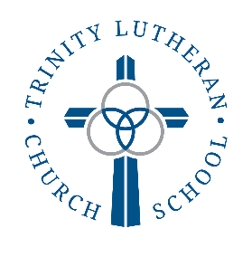
National Lutheran Schools’ Week - 2023
Making Disciples For Life
Matthew 28:19-20

Date | Theme | - Dress Up | Special Activities
Sun 1/22 |  | Dress Up for Worship | 8:45 Fellowship in the Lounge  9:00 Worship with ALL Choirs Singing  10:00 Fellowship in the Lounge  10:15 Adult Bible Study & Sunday School
Mon 1/23 | Children | Trinity Spirit Wear | - Penny War  - 8:00 -Pep Rally and Devotion by Student Council - gym  - Staff vs gr.8 event in gym immediately after Pep Rally  - 12:30-2:00 ~ Sledding for Gr K/2 and Grades 4/5
Tue 1/24 | All Nations | Wacky Day | - Penny War  - 8:00 - SLC Devotion by Mr. Stengl followed by Bible Bee (parents are welcome to attend)
Wed 1/25 | Church | Kaleidoscope of Color | - 9:45 All School Photo in Sanctuary  - 10:00 Chapel led by Pastor Mayland  - Penny War  - McD/Subway Lunch for Childcare through Grade 3
Thu 1/26 | Disciplers | Kingdom Builder –  (get creative with the school year’s theme) | - Penny War  - 8:00 –SLC Devotion by Penny Swanson  - 8:30-9:30 Classroom “Time to Create”  - McD/Subway lunch for Grades 4-8
Fri 1/27 | Families | Class Identity | - Penny War  - 9:30-10:00 ~Veggie Tales with Chapel Families w/ popcorn  - 12:30-2:00 ~ Sledding for Grade 1/3 and Grades 6,7,8

- Penny War has a separate flyer for more information.

