February 2023
Butterfly Room
Sunday | Monday | Tuesday | Wednesday | Thursday | Friday | Saturday
 |  |  | 1 | 2 | 3 | 4
Groundhog Day |  |  | Music
5 | 6 | 7 | 8 | 9 | 10 | 11
Dr. Seuss |  |  | Music |  | Spirit Day Wear Trinity Blue
12 | 13 | 14 | 15 | 16 | 17 | 18
Hearts | Chapel @ 10:00  Georgia’s Birthday | Valentine’s Day  Party 9:00 | Music | Mrs. Penny Reads | No School  Not Hot Lunch
19 | 20 | 21 | 22 | 23 | 24 | 25
Dentist/  Teeth |  | 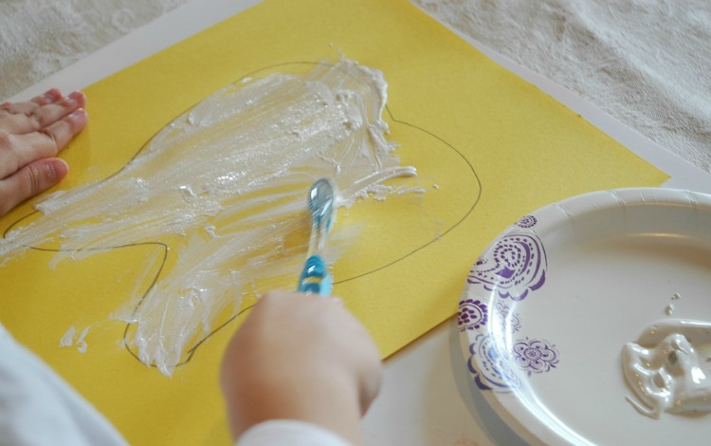 | Music
26 | 27 | 28
5 Senses |  | 